

NOUVELLE LICENCE

**CESSY-GEX FC**

**SAISON 2017-2018**

*Pack avec la* *licence*

*Equipements avec la licence*

***T-shirt + short +***

***chaussettes***

***U9 = 115 €***

***U11 à U13 = 125 €***

***U15 à U17 = 135 €***

***U19 à Senior = 145* €**

|  |  |  |  |  |  |  |  |  |  |  |
| --- | --- | --- | --- | --- | --- | --- | --- | --- | --- | --- |
| *Taille du T-shirt* | | | | | | | | | | |
| 116cm  6ans | 128cm  8ans | 140cm  10ans | 152cm  12ans | 164cm  14ans | 176cm  16ans | S | M | L | XL | XXL |
|  |  |  |  |  |  |  |  |  |  |  |

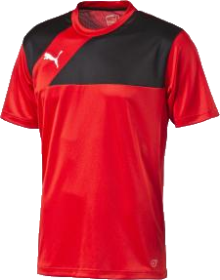

|  |  |  |  |  |  |  |  |  |  |  |  |
| --- | --- | --- | --- | --- | --- | --- | --- | --- | --- | --- | --- |
| *Taille du Short* | | | | | | | | | | | |
| 116cm  6ans | 128cm  8ans | 140cm  10ans | 152cm  12ans | 164cm  14ans | 176cm  16ans | S | M | L | XL | XXL | |
|  |  |  |  |  |  |  |  |  |  |  |

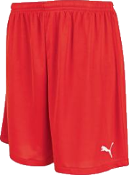

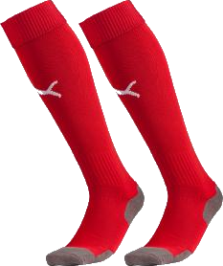

|  |  |  |  |  |
| --- | --- | --- | --- | --- |
| *Taille des Chaussettes* | | | | |
| T.0 = 27-30 | T.1 = 31-34 | T.2 = 35-38 | T.3 = 39-42 | T.4 = 43-46 |
|  |  |  |  |  |

LES OPTIONS AU CHOIX

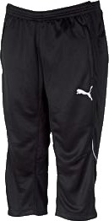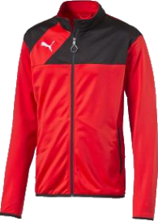

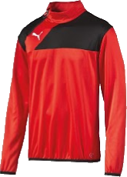

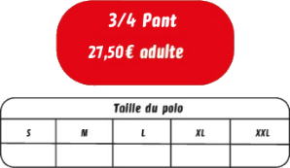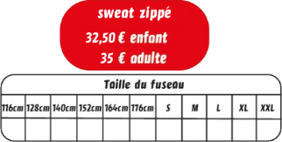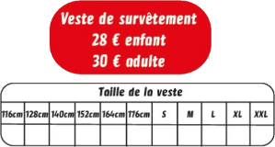

*Taille du fuseau*

*Taille de la veste*

*Taille du pant*

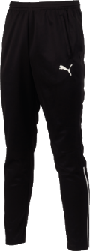

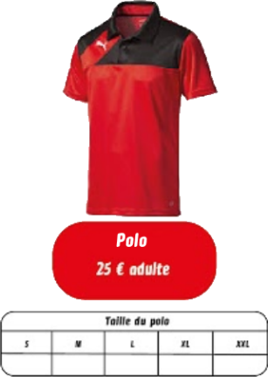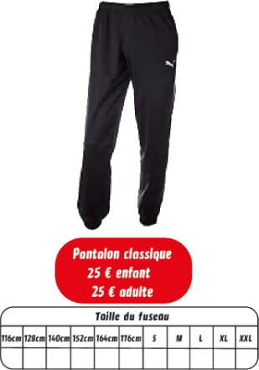T

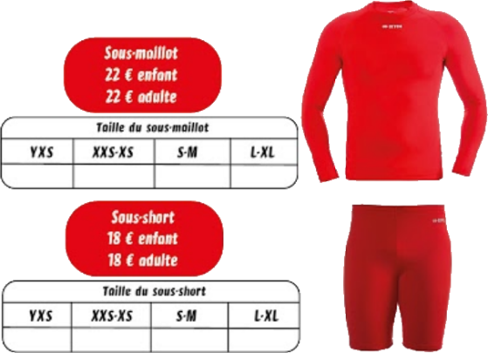

|  |  |
| --- | --- |
| NOM |  |
| Prénom |  |
| Téléphone |  |
| Equipe |  |
| Règlement |  |

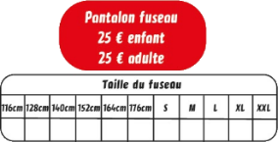

*Taille du pantalon*

*Taille du fuseau*

*Taille du sous-maillot*

*Taille du sous-short*

*Taille du polo*

|  |  |  |  |  |
| --- | --- | --- | --- | --- |
| Articles | Référence | Taille | Qté | Prix |
| **Pack Licence** |  |  | **1** |  |
|  |  |  |  |  |
|  |  |  |  |  |
|  |  |  |  |  |
|  |  |  |  |  |
|  |  |  |  |  |
| Total de la commande | | | |  |