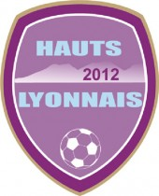
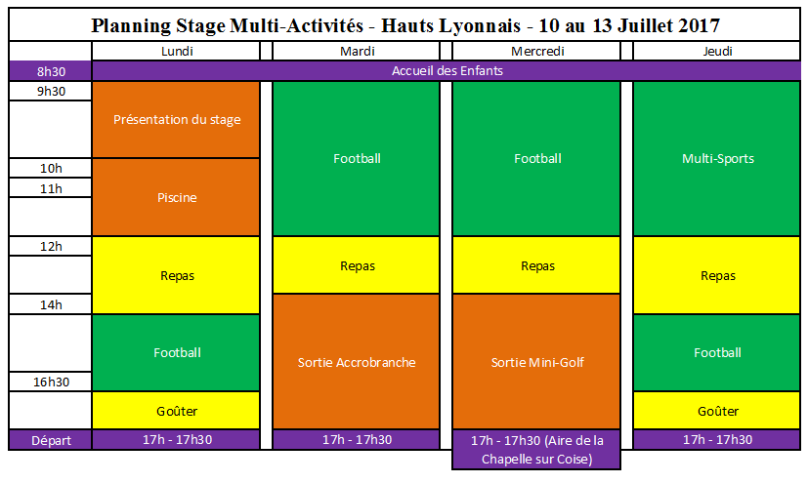
PLANNING STAGE MULTI-ACTIVITES – HAUTS LYONNAIS 2017

